Experiment 47

ACOUSTIC DIFFRACTION AND INTERFERENCE

APPARATUS: Ultrasonic crystals, audio generator, oscilloscope, and audio voltmeter.

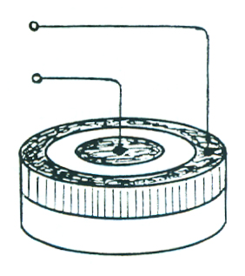
REFERENCES: T.D. Rossing, The Science of Sound, Sections 3.10, 3.11; A.M. Portis and H.D. Young, Berkeley Physics Laboratory, 2nd ed. (McGraw-Hill, New York, 1971). AF-2; F.W. Sears, M.W. Zemansky, and H.D. Young, College Physics, 5th ed. (Addison-Wesley, Reading, MA, 1980). Chapter 42.

DISCUSSION:
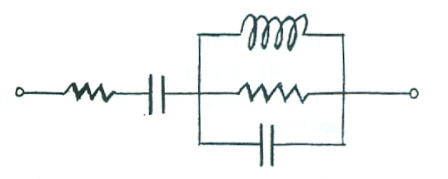
This experiment makes use of the same ultrasonic transducers used to determine the speed of sound in Experiment 9. These transducers, which were developed for the remote control of television receivers, consist of discs of peizoelelctric barium titanate bonded to aluminum. Two electrodes are attached to each barium titanate disc and applying a voltage to these electrodes causes the BaTiO3 to warp, thus exciting a strong mechanical resonance at 40 kHz in the aluminum disc (other resonances can also be observed at high frequencies. An equivalent electrical circuit for the transducer is shown.

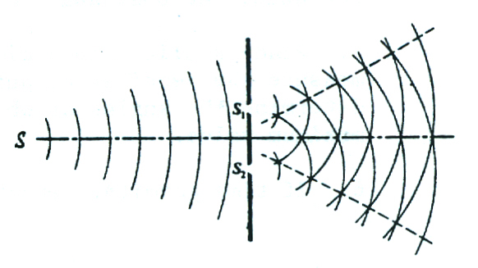
Many classical optics experiments can be conveniently performed using these transducers to generate and detect ultrasonic single-slit diffraction, two-slit interference, and Lloyd’s mirror. In addition, the radiation pattern of a single transducer will be explored.

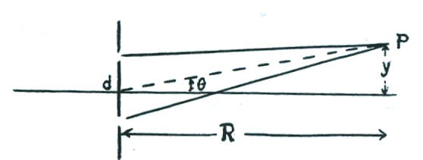
One of the earliest demonstrations of wave interference was performed by Thomas Young around 1800. Waves from source S pass through slits S1 and S2 and interfere in the region beyond them. Constructive interference will occur at point P located so that y = R nλ/d where d is the distance between the slits, λ is the wavelength, and n is an integer

Lloyd’s mirror may be thought of as a variation of Young’s experiment in which the image S¹ of source S acts as the second source. Because there is a reversal of phase upon reflection at the table top, however, S and S¹ act as sources with opposite phase (compare Fig. 25.2 in Rossing)
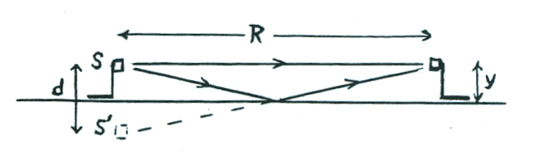
Therefore, constructive interference should occur when ;
but y - d/2, so we can write
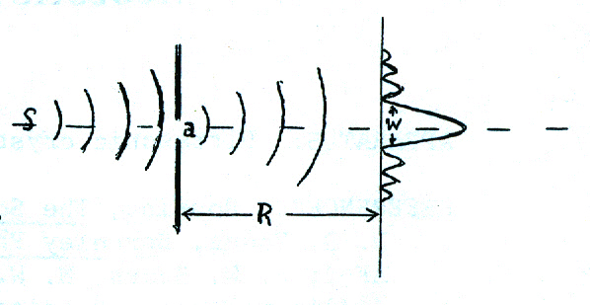

as the condition for a maximum.

The diffraction pattern of a single slit consists of a central maximum along with secondary maxima on either side. The width w of the central maximum is given approximately by , where a is the width of the slit.

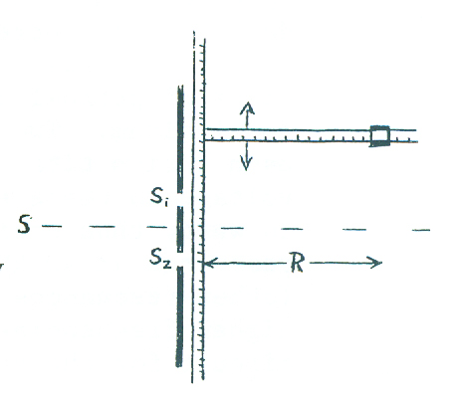
PROCEDURE:
1. Set up the transmitting and receiving crystals as described in Experiment 9. Either measure the wavelength (as in Step 2) or calculate it from the measured frequency.

2. Place one crystal about 50 cm away from a pair of slits having a spacing of about 5 cm. With R = 50 cm, measure y for 5-7 maxima (2 or 3 on each side of the central one). Compare these values of y to those predicted by the formula again.

3. Using the Lloyd’s mirror arrangement, measure as many different values or R as you can (including the one for n = 1). Compare these values to those predicted by the formula.

4. Connect an audio voltmeter (VTVM) across the receiver crystal in order to more accurately measure small voltages. Carefully measure the output of the receiving transducer placed at intervals of 15° on a semicircle with the transmitter at the center. Determine the average angles at which the signal drops to one half of its value on the axis. At what angle does it drop to one tenth of its maximum value?

5. Place a slit with a width of about 2λ about 20 cm away from the transmitter and measure the receiver output on a semicircle with the slit at the center. Again determine the angles at which the signal drops to one half and one tenth of its maximum value.

6. If time permits, repeat Step 5 with a slit having a width of about ½.

